--=================================================================================
--=============================== CIS 310 Exercise 1 ===============================
--=================================================================================
/*
STUDENT NAME: Dylan Shea
STUDENT ID: 5505131
SUBMISSION DATE:1/11/2024
*/
- Do you spot any data redundancies in given data table? If so, what are the redundancies?
- Explain the 3 types of data anomalies using below table. Update, Insertion, and Deletion.
-- Your explanation should refer to specific data as shown. Such as “ When Project manager is…….It causes…..”
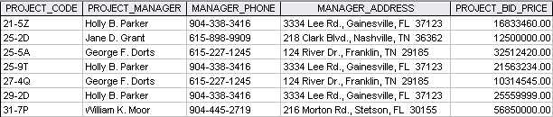
1. Data Redundancy: Holly B. Parker is listed as the project manager on 3 separate projects, George F. Dorts is also listed as the project manager on 2 separate projects.

2a. Update Anomaly: an Update Anomaly would happen if one of the project managers changed their address and/or phone number and needed to update every row

2b. Insertion Anomaly: Adding in a new project manager, they would not be assigned to a project right away creating the anomaly.

2c. Deletion Anomaly: If you were to delete Holly B. Parker’s data, for example she quit or got fired, you would lose the data for the project price and code.

